**SALARY SURVEY**

**FOR 2021**

**MYTHILI K S**

**DADS – OCTOBER BATCH**

**KGISL MICRO COLLEGE, COIMBATORE**

|  |  |  |
| --- | --- | --- |
| **S. No** | **Table of Contents** | **Page** |
| 1 | Introduction | 3 |
| 2 | Data Cleaning | 4 |
| 3 | Data Import | 5 |
| 4 | SQL Queries | 6 |
| 5 | Data Modeling | 10 |
| 7 | Dashboard | 11 |
| 8 | Insights and Recommendation | 12 |

**INTRODUCTION**

* Conducted the analysis of the given dataset which is the Salary survey for the year 2021.
* Cleaned the given raw dataset.
* Imported into MySql.
* Queried the Data required for Dashboard Creation and Exported.
* Created Dashboard to visualize the trends and analysis.

**DATA CLEANING**

* The given dataset is about the salary survey for the year 2021
* It contains Industries, job titles, their annual salaries, compensations, currencies.
* Also, their age range, experience, qualification, gender, Countries, cities and states.
* Handled missing values, inconsistent values and standardized the data types
* Hence the dataset was cleaned

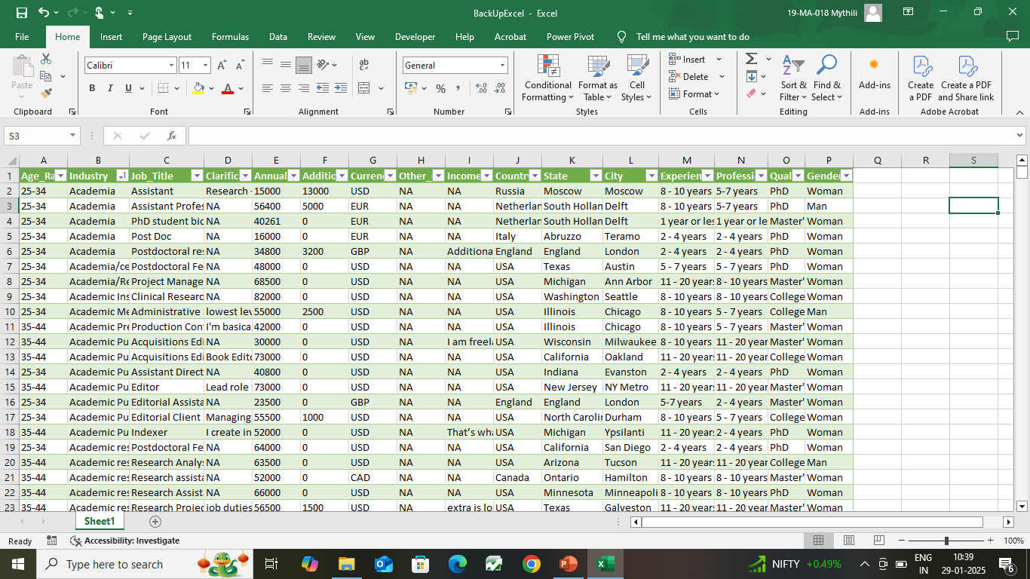

**DATA IMPORT**

* Uploaded the cleaned dataset into MySql database.
* Imported using “Data import wizard”
* Applied some Queries required for dashboards.

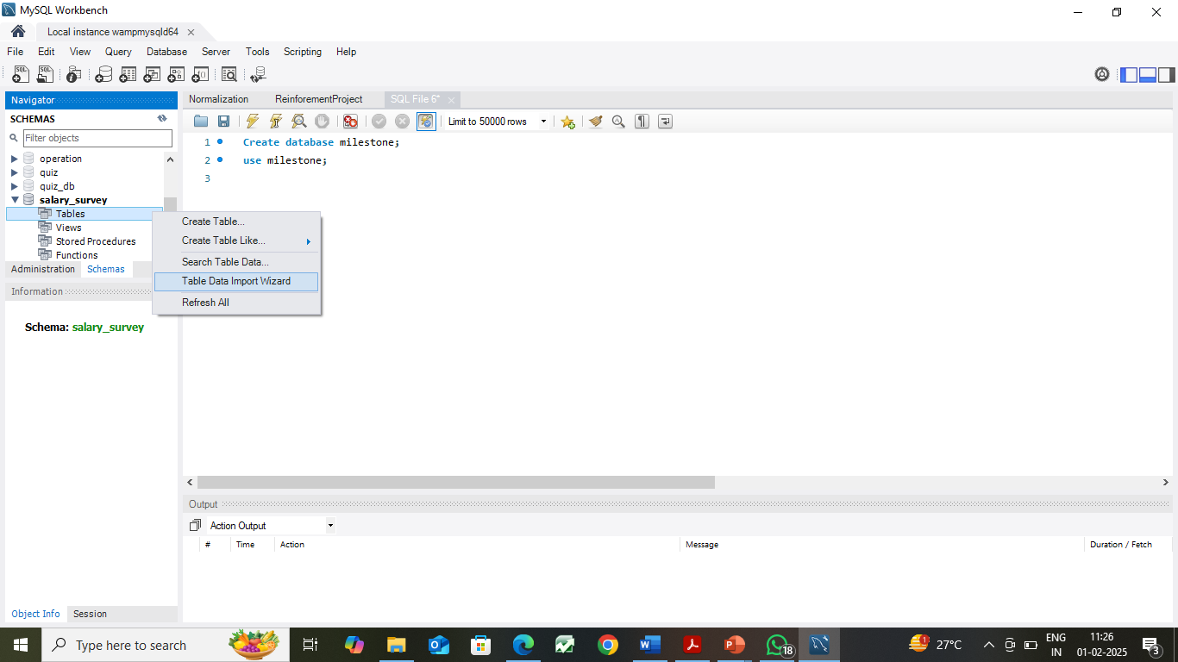

**SQL QUERIES**

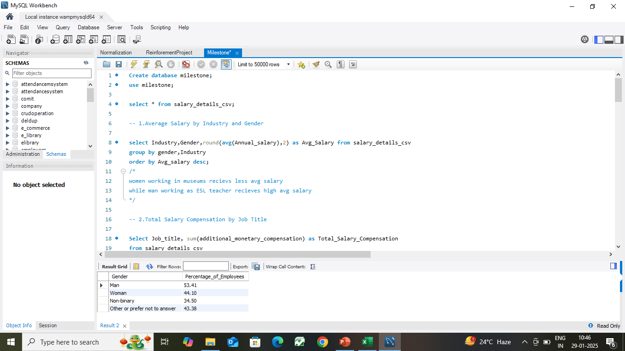

**1.Average Salary by Industry and Gender:**

select Industry,Gender,round(avg(Annual_salary),2) as Avg_Salary from salary_details_csv

group by gender,Industry

order by Avg_salary desc;

**2.Total Salary Compensation by Job Title:**

Select Job_title, sum(additional_monetary_compensation) as Total_Salary_Compensation

from salary_details_csv

group by Job_Title

order by Total_Salary_Compensation desc;

**3.Salary Distribution by Education Level:**

Select Qualification, round(avg(annual_salary),2) as Avg_Salary,

min(annual_salary) as Min_Salary,

max(annual_salary) as Max_Salary,

abs(min(annual_salary) -max(annual_salary)) as Distribution

from salary_details_csv

group by Qualification

order by distribution desc;

**4.Number of Employees by Industry and Years of Experience:**

Select Industry, Professional_experience, count(age_range) as No_of_Employees

from salary_details_csv

group by Professional_Experience,Industry

order by No_of_Employees desc;

**5.Median Salary by Age Range and Gender:**

WITH RankedSalaries AS (

SELECT

Annual_salary,

age_range,

gender,

ROW_NUMBER() OVER (PARTITION BY age_range, gender ORDER BY Annual_salary) AS row_num,

COUNT(*) OVER (PARTITION BY age_range, gender) AS total_count

FROM salary_details_csv

)

SELECT age_range, gender,

CASE

WHEN total_count % 2 = 1 THEN

MAX(CASE WHEN row_num = (total_count + 1) / 2 THEN Annual_salary END)

ELSE

AVG(CASE WHEN row_num IN (total_count / 2, total_count / 2 + 1) THEN Annual_salary END)

END AS median_salary

FROM RankedSalaries

GROUP BY age_range, gender ORDER BY age_range;

**6.Job Titles with the Highest Salary in Each Country:**

SELECT country, job_title, MAX(annual_salary) AS Highest_Salary

FROM salary_details_csv

GROUP BY Job_Title

ORDER BY Highest_Salary Desc;

**7.Average Salary by City and Industry:**

Select City, Industry, avg(annual_salary) as Avg_salary

from salary_details_csv

group by Industry

order by Avg_salary desc;

**8.Percentage of Employees with Additional Monetary Compensation by Gender:**

Select Gender, round(((count(case when Additional_Monetary_Compensation>0 then age_range end)/count(age_range))*100),2) as Percentage_of_Employees

from salary_details_csv

group by gender;

**9.Total Compensation by Job Title and Years of Experience:**

select job_title,Professional_experience,

sum(Additional_Monetary_Compensation) as Total_Compensation

from salary_details_csv

group by Professional_experience

order by total_compensation desc

**10.Average Salary by Industry, Gender, and Education Level:**

Select Industry,Gender,Qualification,avg(annual_salary) as Avg_Salary

from salary_details_csv

group by industry,gender,Qualification

order by Avg_salary desc;

**DATA MODELING**

* After running each SQL query, exported the result to a CSV file.
* Created separate sheets in Excel for each query result.
* Created relations among tables.

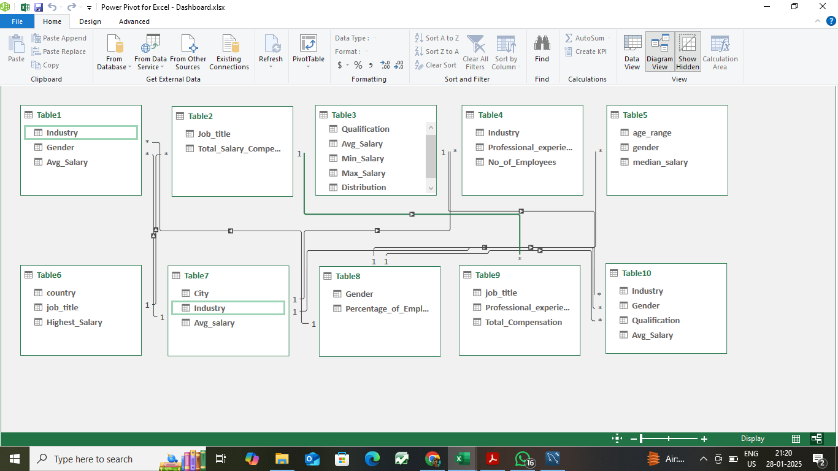

**DASHBOARD**

* Created Pivot Tables and charts.
* Added Slicers.
* Implemented KPI’s.

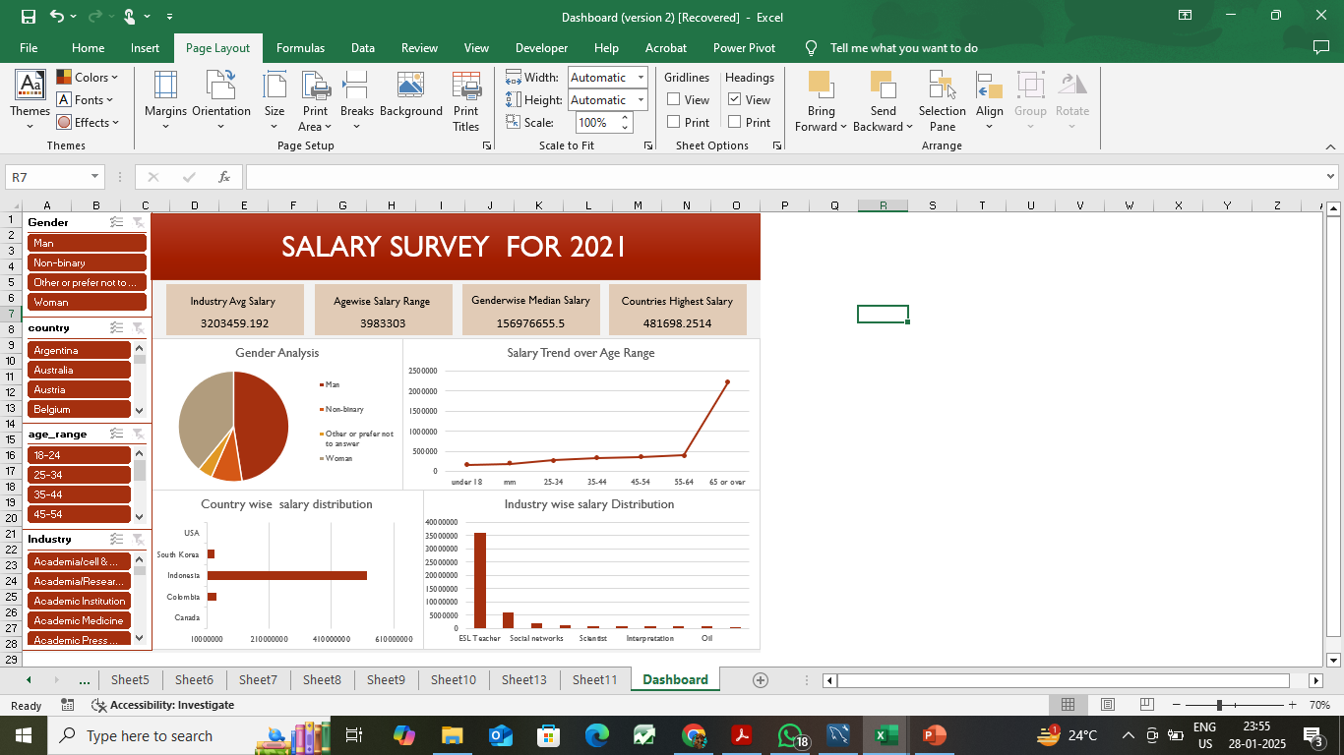

**PRESENTATION**

PPT Link: [MilestonePPT](Milestone%20PPT.pptx)

**INSIGHTS AND RECOMMENDATION**

**Insights:**

* Men compensations salary is high while compared to others
* “Investment banking Analyst” job role has High salary.
* Among cities, Seoul tops the list and it is by ESL Teachers.
* People with PhD degree has highest salary range.
* “Computing or tech” has High no. of employees.

**Recommendations:**

* Recruit people regardless of Genders
* Other Industries should also be concentrated in Developing and Improvement.
* Countries having people with high salaries but their numbers are less. So that, should be concerned